**Reliable Solution Incorporation**

**Company Introduction**

**Welcome to RELIABLE SOLUTION INC.**

We are Reliable Solution incorporation, since 2016 we’re passionate about harnessing the power of technology to drive innovation and solve real-world problems. As a cutting-edge software company, we’re dedicated to creating intuitive, user-friendly solutions that make a meaningful impact on businesses and individuals alike.

Reliable Solution Incorporation provides developer teams instant access to a cloud platform that allows them to test their websites and mobile applications for functionality, performance, and visual appeal so they can release bug-free software faster and at scale.



**Our Mission**

Our mission is to empower organizations and individuals with innovative software solutions that enhance productivity, efficiency, and growth. We’re committed to delivering high-quality products that exceed our clients’ expectations and make a lasting difference in their lives. We ensure

Imagine a workplace where employees come to work inspired, feel safe, share a common purpose with peers and leaders, do their best work, and go home fulfilled. We are on a mission to make this happen across the world.

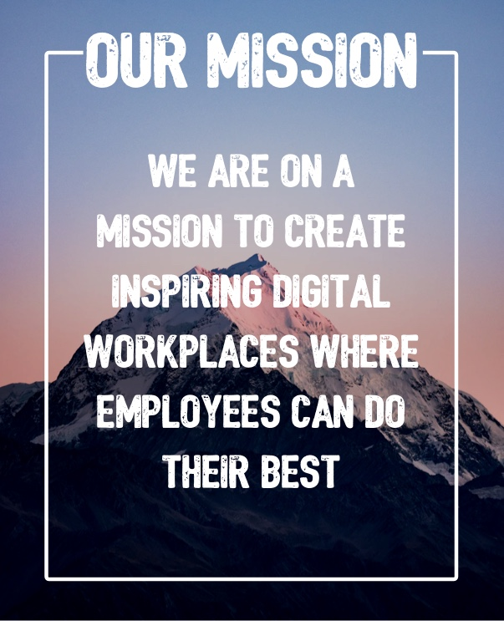

**OUR TEAM**

# When great people work together, awesome happens

# We are a bunch of fun loving and good humans each with their own passions and goals, but united by a journey and a mission.

## **Our people make all the difference**

We are an organization built by our employees. The passion and the extreme ownership that our people bring to the table is contagious. We don’t hide and we aren’t afraid to ask for help. When we fail we learn, adapt, and do better in the future. This open culture encourages our people to innovate, regardless of their function and across departmental boundaries.

**What We Do**

Reliable solutions Incorporate specializes in developing specific area of software development, e.g., mobile apps, web applications, AI-powered solutions, etc. Our team of expert developers, designers, and innovators work collaboratively to craft bespoke software solutions that cater to the unique needs of our clients.

**Our Values**

**- Innovation:** We believe in pushing the boundaries of what’s possible with technology.

**- Quality:** We’re committed to delivering top-notch solutions that meet the highest standards.

**- Customer- centricity:** Our clients are at the heart of everything we do.

**- Collaboration:** We foster a culture of teamwork and open communication.

###### **Our purpose**

## **Join our purpose. Not because we are cool or you are cool**

We have a purpose and we are serious about it. The tools we use and the cools we do are just part of our journey. We are on a mission to make every employee a growth enabler in every small medium business across this nation and the other nations.



## **Skills matter some. Attitude matters most**

Skills are mere tools to accomplish tasks and can be learnt and unlearnt any time. But the attitude you bring to the table when solving obstacles, makes all the difference and gives purpose to those skills and the people around you. That’s what matters to us most. If you like this notion - we are excited and can’t wait to talk to you! Explore the job openings below and apply now!

**Join Us on This Journey**

As we embark on this exciting journey, we invite you to explore our solutions, share your feedback, and join our community of innovators. Together, let’s shape the future of software development and create a better world through technology.

This introduction provides a solid foundation for your company’s identity, mission, and values. Feel free to customize it to fit your unique vision and brand.

**Who we are**

**What drives Us:**

Our mission is to be the testing platform for the internet, helping developers and testers build amazing experiences.

**Build, Break, Innovate:**

Join a team of thinkers, creators, and problem-solvers who love turning big ideas into reality.

**Work from Anywhere:**

As a remote-first company, we offer the flexibility to work where you’re most inspired, united by our shared values.